Irregular Polygon Tessellation
# Source: AI Source: Provided by: [Data Path: Persons Table -> ID Column: 1, Name_En Column: Motasem Essam] -> From: [ChatGPT] on [7/25/2026]
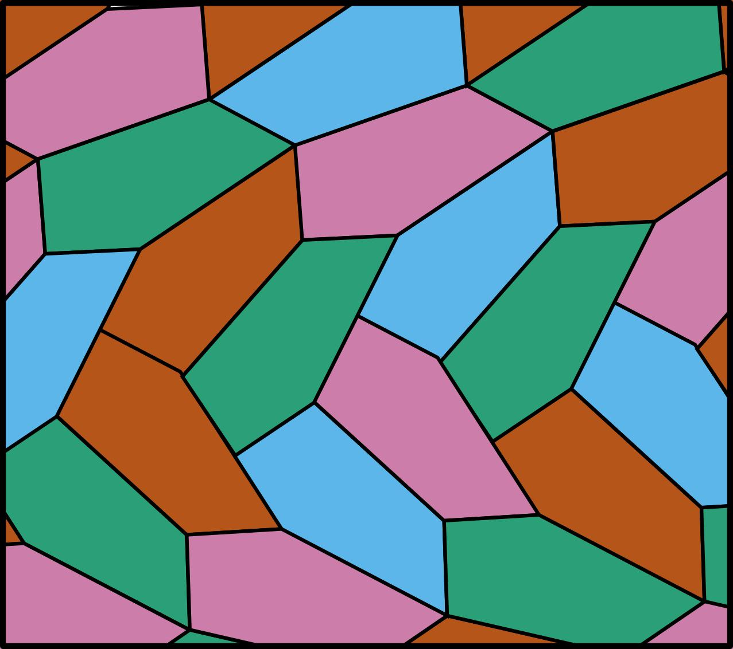
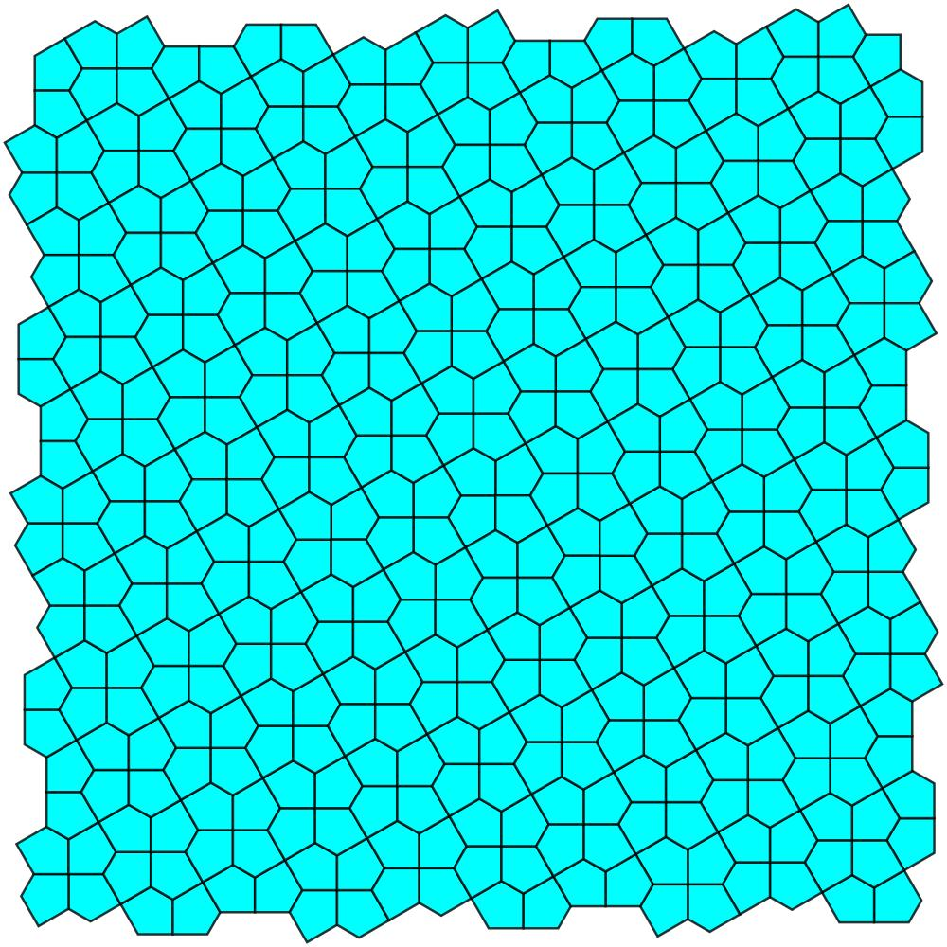
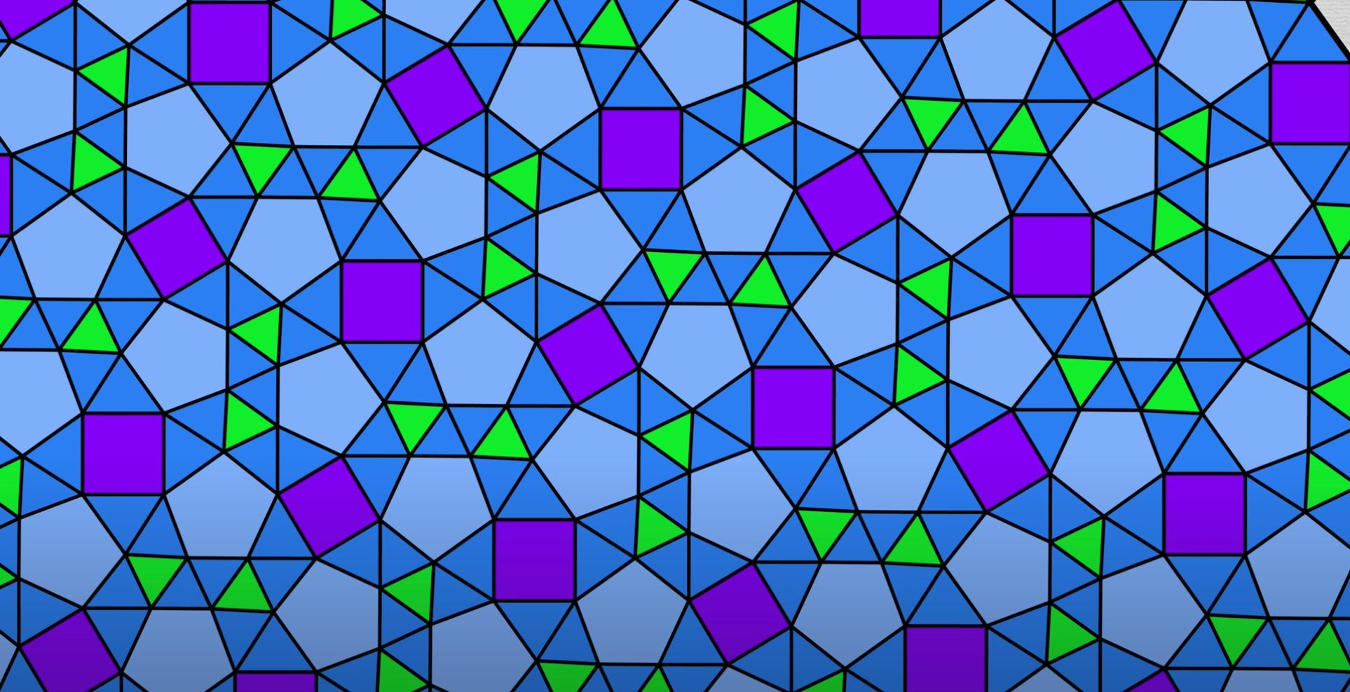
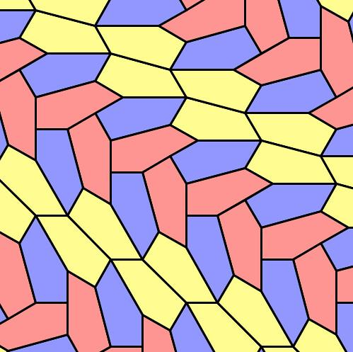
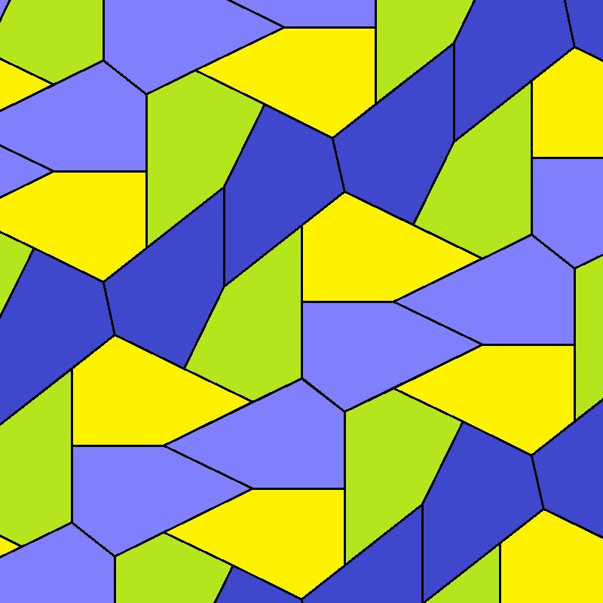

Definition
# Source: AI Source: Provided by: [Data Path: Persons Table -> ID Column: 1, Name_En Column: Motasem Essam] -> From: [ChatGPT] on [7/25/2026]
An Irregular Polygon Tessellation is a tessellation of the plane that uses one or more irregular polygons to completely cover the plane without gaps or overlaps.
An irregular polygon is a polygon that is not regular: its sides are not all equal, its angles are not all equal, or both. (Math Open Reference)
Therefore:
$$\boxed{\text{Irregular Polygon Tessellation}=\text{Tessellation using irregular polygons}}$$
Irregular polygons can successfully tessellate the plane even though they do not have the uniform side lengths and angles of regular polygons. (OpenStax)

Basic Structure
# Source: AI Source: Provided by: [Data Path: Persons Table -> ID Column: 1, Name_En Column: Motasem Essam] -> From: [ChatGPT] on [7/25/2026]
An irregular polygon tessellation can use:
- one type of irregular polygon;
- several different irregular polygons;
- congruent copies of one irregular polygon;
- or different sizes and shapes of irregular polygons.
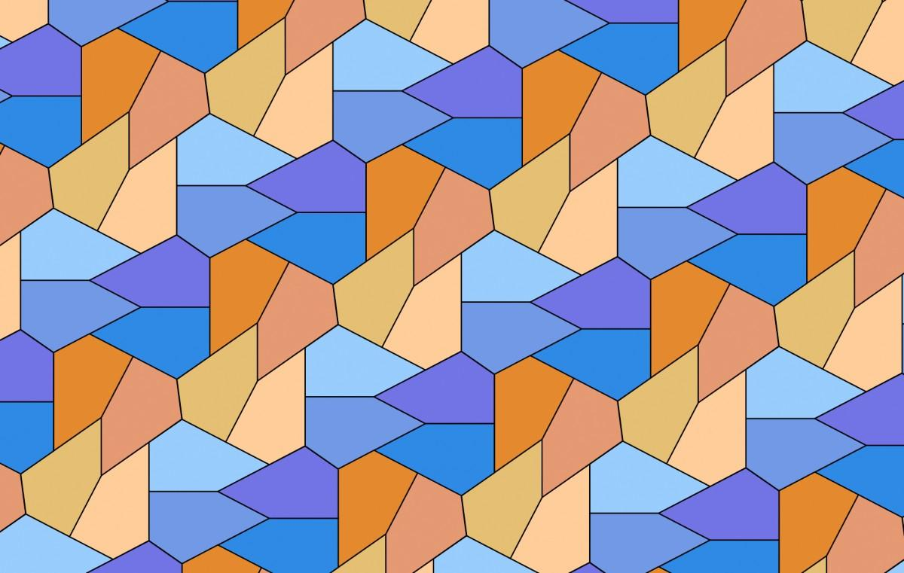
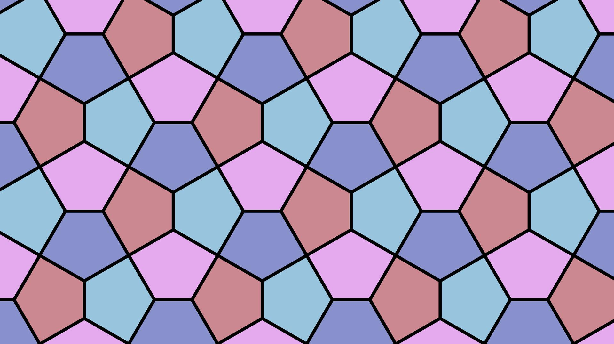
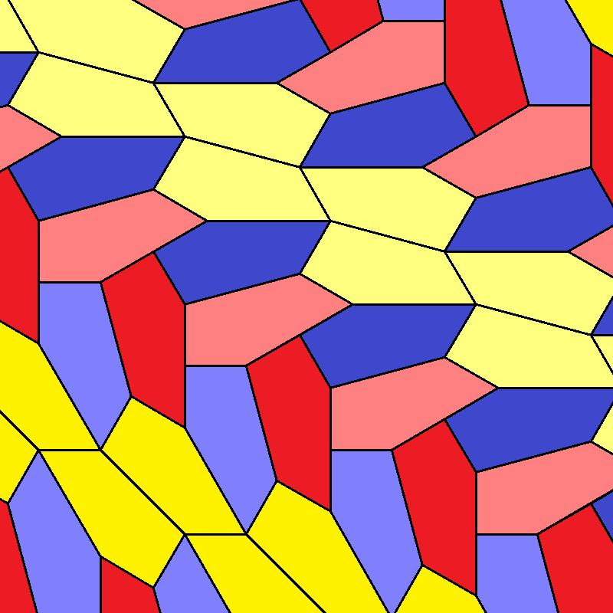
The fundamental requirement remains:
$$\boxed{\text{No Gaps}+\text{No Overlaps}+\text{Complete Plane Coverage}}$$
This is the defining requirement of a tessellation.

Example: Irregular Pentagon Tessellation
# Source: AI Source: Provided by: [Data Path: Persons Table -> ID Column: 1, Name_En Column: Motasem Essam] -> From: [ChatGPT] on [7/25/2026]
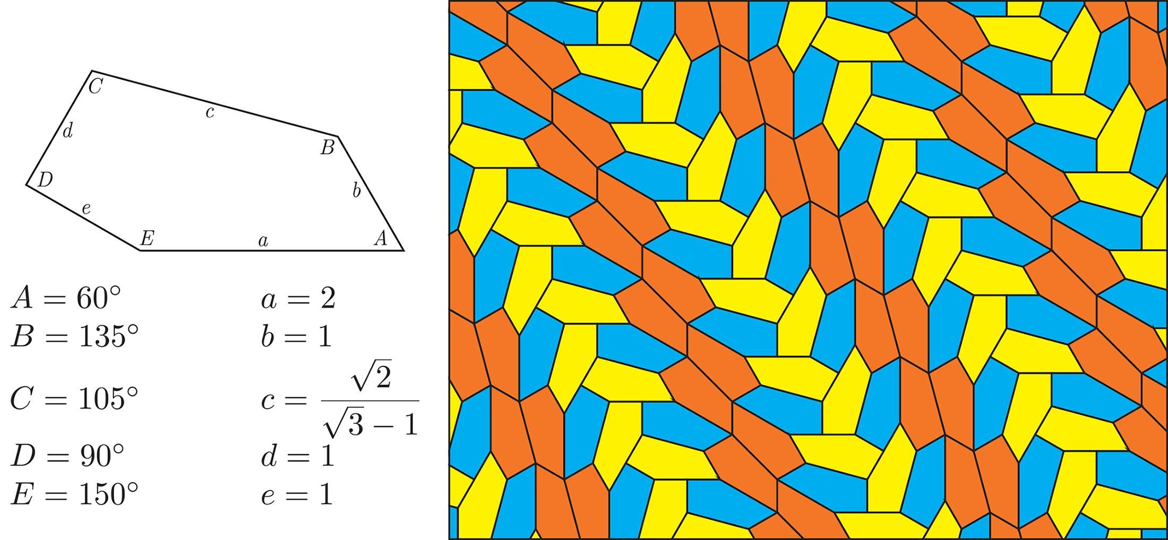
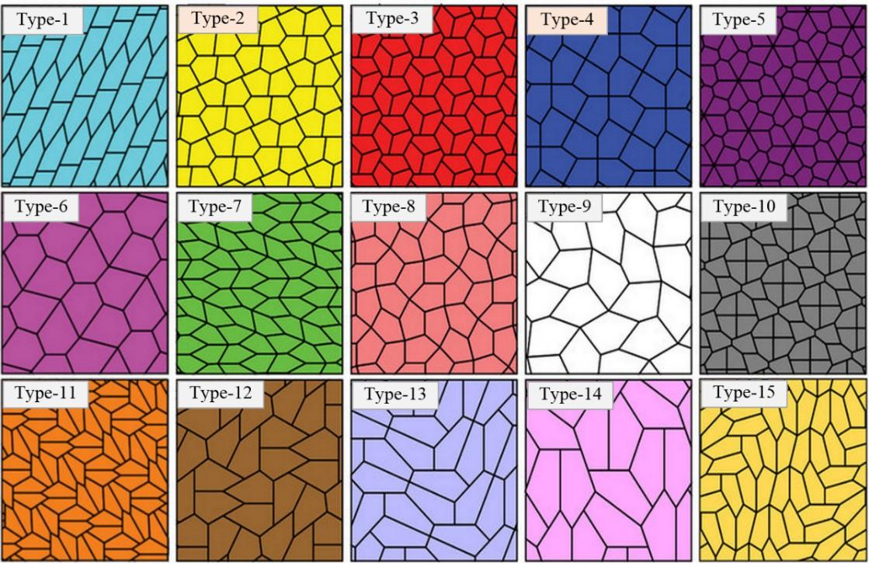
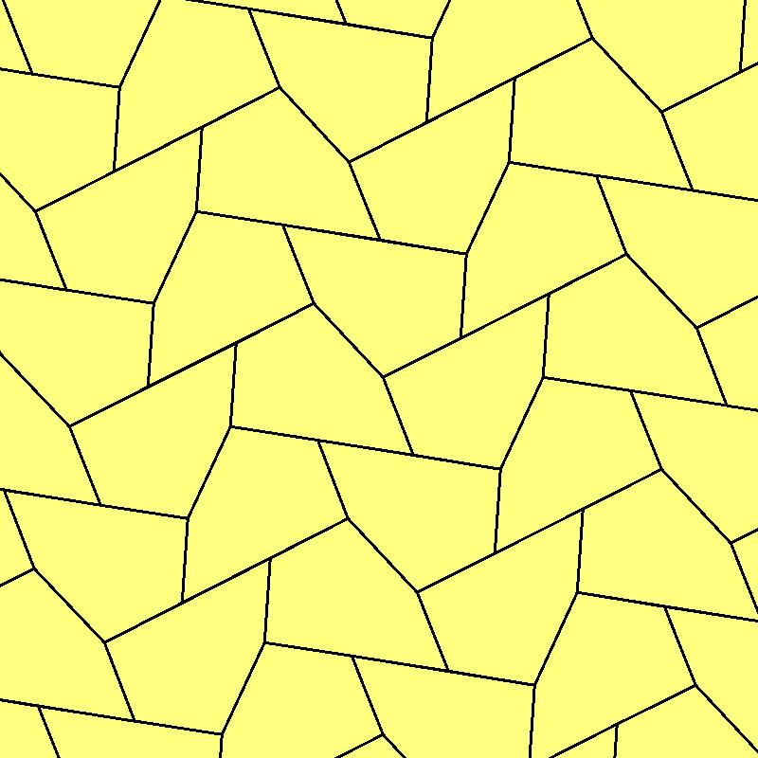
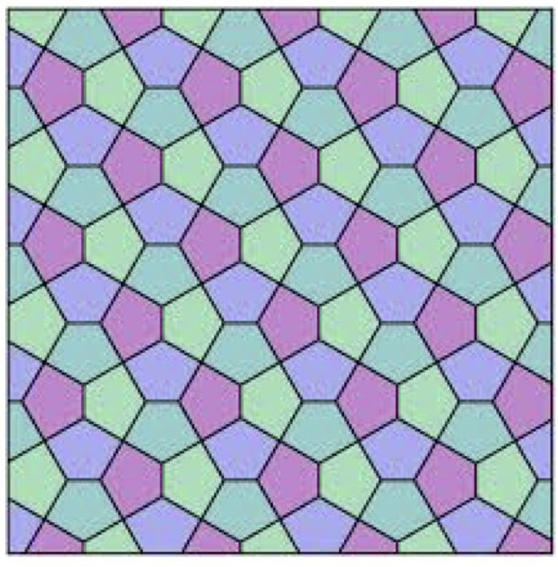
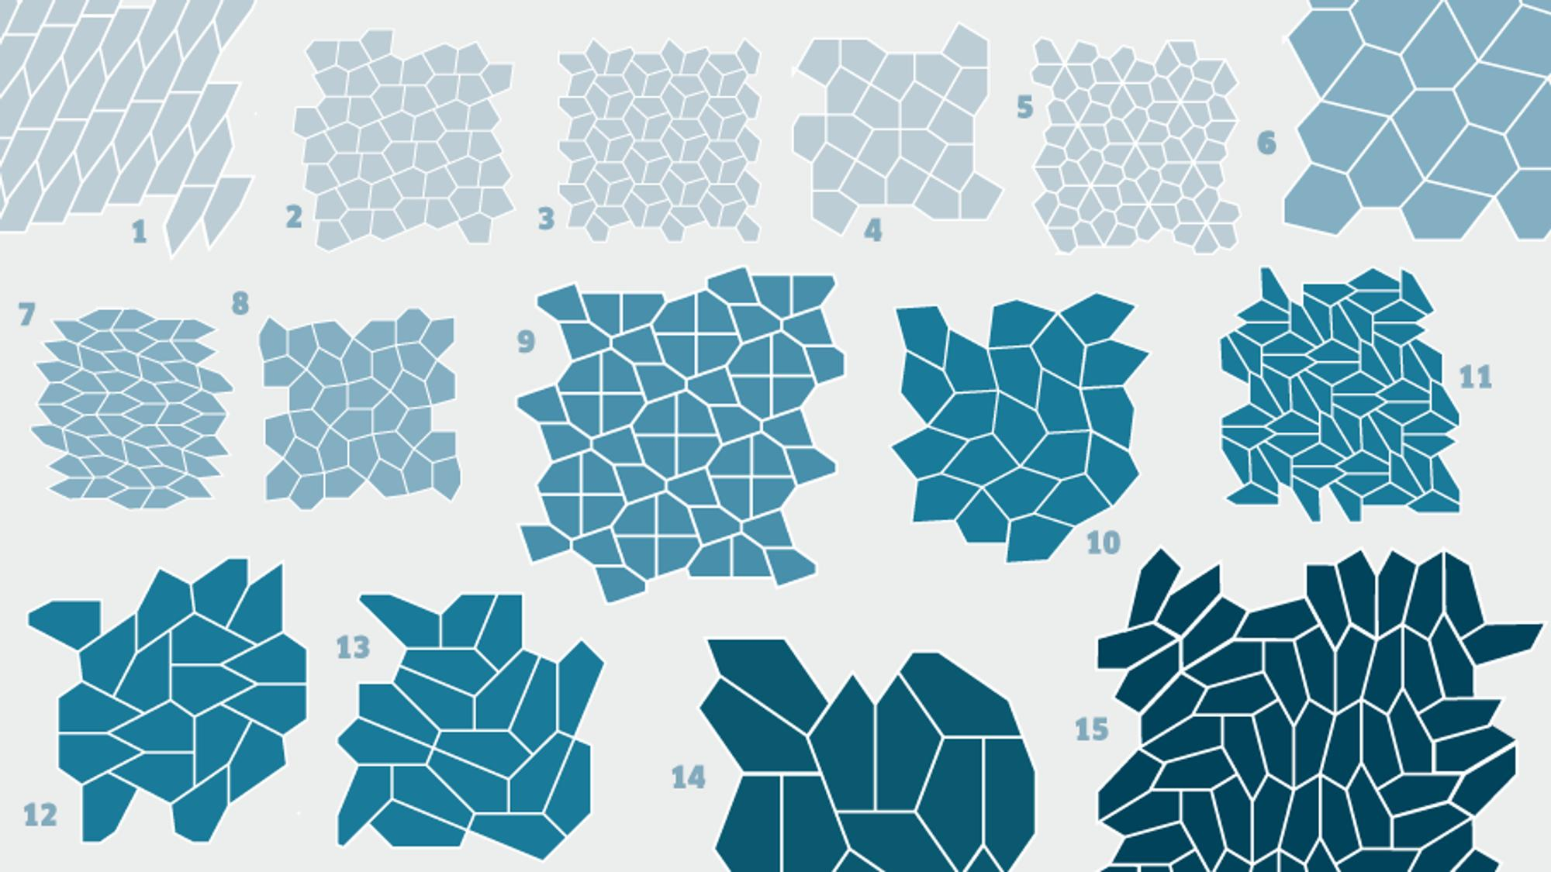
Irregular pentagons provide an important example.
A regular pentagon cannot tessellate the Euclidean plane by itself, but certain irregular pentagons can. Mathematical research has identified families of convex pentagons capable of tiling the plane. (OpenStax)
The important point is that changing the side lengths and angles can make a polygon fit with neighboring copies in a way that a regular pentagon cannot.

Example: Irregular Triangle Tessellation
# Source: AI Source: Provided by: [Data Path: Persons Table -> ID Column: 1, Name_En Column: Motasem Essam] -> From: [ChatGPT] on [7/25/2026]
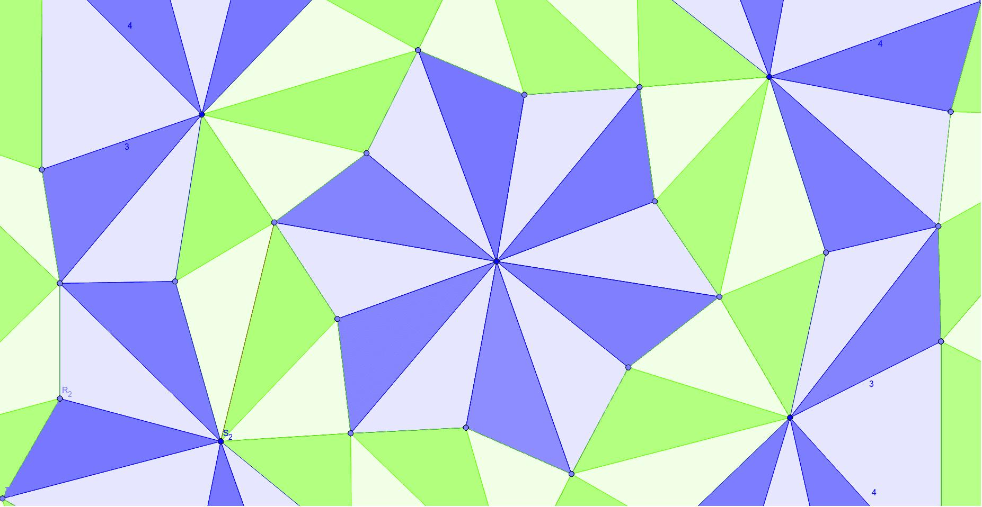
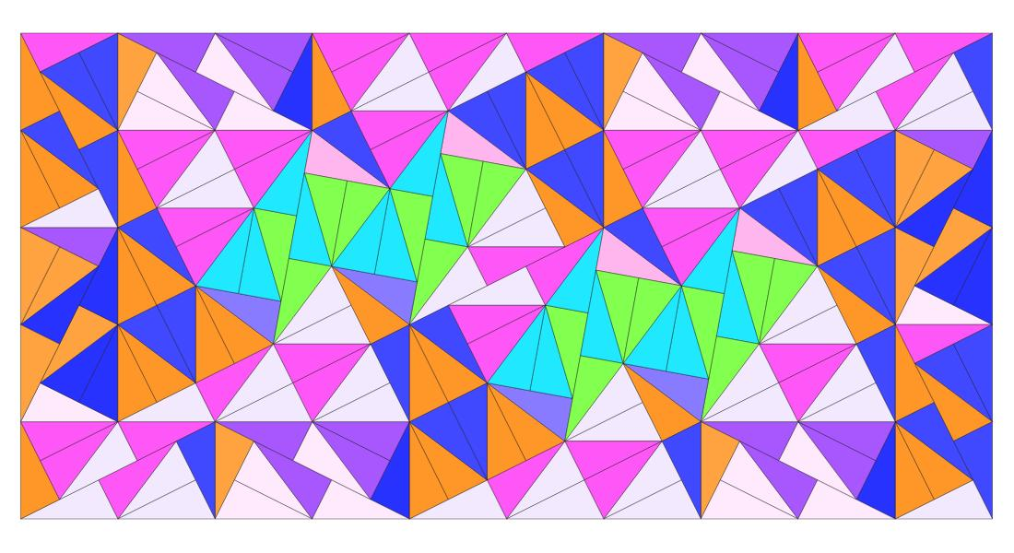
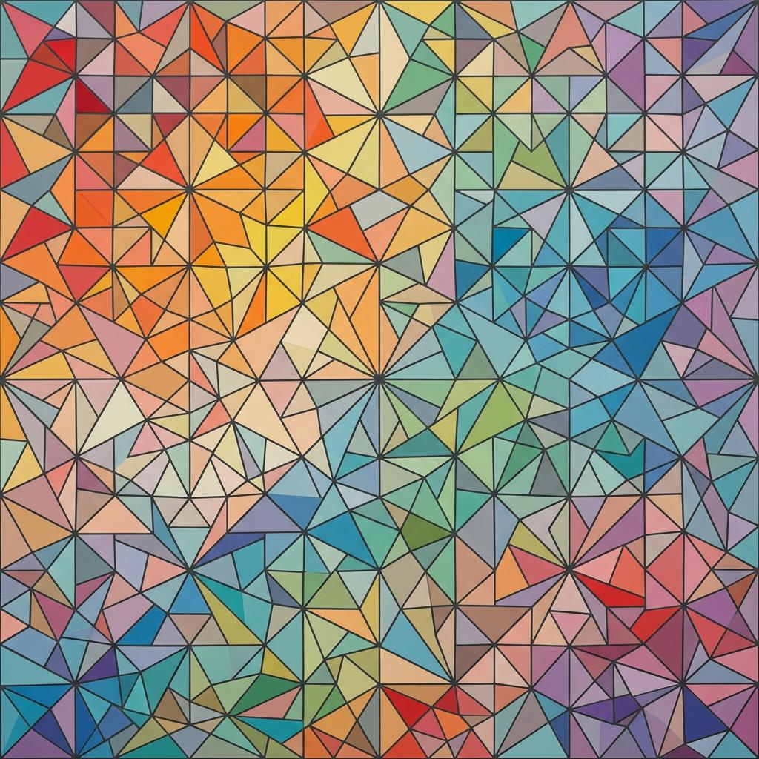
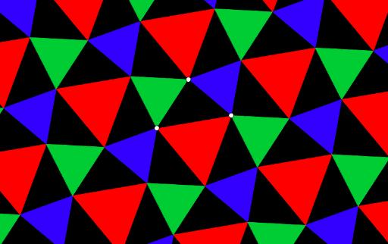
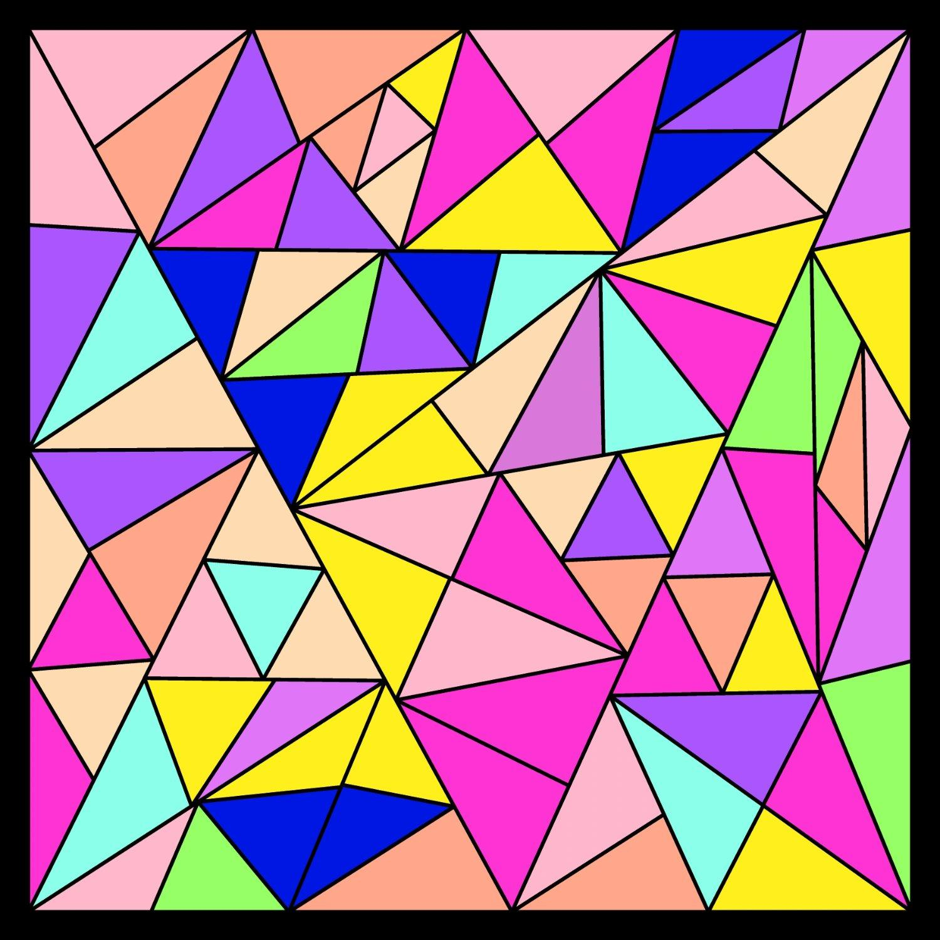
An irregular triangle can also tessellate the plane.
For example, an irregular triangle can be reflected and translated to create a repeating arrangement. OpenStax gives an example using an obtuse irregular triangle and transformations to produce a tessellation. (OpenStax)
This demonstrates an important fact:
A polygon does not need to be regular to tessellate.

How Does an Irregular Polygon Tessellate?
# Source: AI Source: Provided by: [Data Path: Persons Table -> ID Column: 1, Name_En Column: Motasem Essam] -> From: [ChatGPT] on [7/25/2026]
The key geometric condition is that the polygons must fit together around their vertices.
For example, if four angles meet at a point:
$$\boxed{θ_{1}+θ_{2}+θ_{3}+θ_{4}={360}^{∘}}$$
then they can potentially fit around that point without leaving an angular gap.
However, angle sums alone are not sufficient to guarantee that an entire polygon can tile the plane. The side lengths, edge matching, and arrangement must also work throughout the complete pattern. (learningcentre.nelson.com)

Monotile vs Multi-Tile
# Source: AI Source: Provided by: [Data Path: Persons Table -> ID Column: 1, Name_En Column: Motasem Essam] -> From: [ChatGPT] on [7/25/2026]
This subtype connects directly to the two categories you just established.
Irregular Monotile Tessellation
Uses one irregular prototile.
$$\boxed{A+A+A+A+⋯}$$
For example, a single irregular pentagon shape can sometimes be repeated to cover the plane.
Irregular Multi-Tile Tessellation
Uses two or more different irregular prototiles.
$$\boxed{A+B+C+A+B+C+⋯}$$
Therefore:
$$\boxed{\text{Irregular Polygon Tessellation}⊃\left\{\begin{matrix}\text{Irregular Monotile} \\ \text{Irregular Multi-Tile}\end{matrix}\right.}$$
This is a useful distinction for your knowledge-base taxonomy.

Irregular Polygon Tessellation vs Regular Tessellation
# Source: AI Source: Provided by: [Data Path: Persons Table -> ID Column: 1, Name_En Column: Motasem Essam] -> From: [ChatGPT] on [7/25/2026]
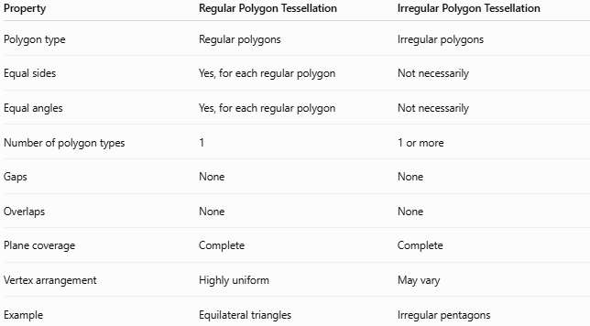
Property | Regular Polygon Tessellation | Irregular Polygon Tessellation
Polygon type | Regular polygons | Irregular polygons
Equal sides | Yes, for each regular polygon | Not necessarily
Equal angles | Yes, for each regular polygon | Not necessarily
Number of polygon types | 1 | 1 or more
Gaps | None | None
Overlaps | None | None
Plane coverage | Complete | Complete
Vertex arrangement | Highly uniform | May vary
Example | Equilateral triangles | Irregular pentagons
There are exactly three regular tessellations made from one type of regular polygon: equilateral triangles, squares, and regular hexagons.

Irregular Polygon Tessellation vs Semi-Regular Tessellation
# Source: AI Source: Provided by: [Data Path: Persons Table -> ID Column: 1, Name_En Column: Motasem Essam] -> From: [ChatGPT] on [7/25/2026]
This distinction is particularly important because you have already studied the Archimedean tessellations.
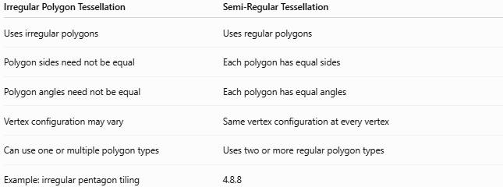
Irregular Polygon Tessellation | Semi-Regular Tessellation
Uses irregular polygons | Uses regular polygons
Polygon sides need not be equal | Each polygon has equal sides
Polygon angles need not be equal | Each polygon has equal angles
Vertex configuration may vary | Same vertex configuration at every vertex
Can use one or multiple polygon types | Uses two or more regular polygon types
Example: irregular pentagon tiling | 4.8.8
For example, 4.8.8 uses squares and octagons, but both are regular polygons, so it belongs to the semi-regular/Archimedean category rather than the irregular-polygon category. (Mathwords)

Classification
# Source: AI Source: Provided by: [Data Path: Persons Table -> ID Column: 1, Name_En Column: Motasem Essam] -> From: [ChatGPT] on [7/25/2026]
For your Plane Geometry knowledge base, I would organize it as:
Tessellations
→ Irregular Tessellations
→ Irregular Polygon Tessellation
And beneath it:
Irregular Polygon Tessellation
- Irregular Monotile Tessellation
- Irregular Multi-Tile Tessellation
Then periodicity can be treated as a separate classification dimension:
- Periodic Irregular Polygon Tessellation
- Non-Periodic / Aperiodic Irregular Polygon Tessellation
This prevents "number of tile types," "polygon regularity," and "periodicity" from being mixed together.

Properties
# Source: AI Source: Provided by: [Data Path: Persons Table -> ID Column: 1, Name_En Column: Motasem Essam] -> From: [ChatGPT] on [7/25/2026]
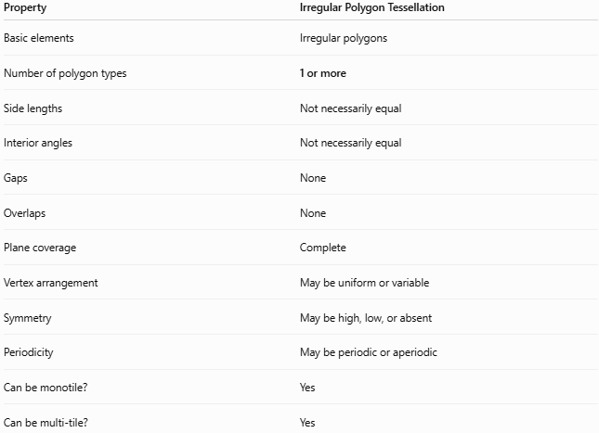
Property | Irregular Polygon Tessellation
Basic elements | Irregular polygons
Number of polygon types | 1 or more
Side lengths | Not necessarily equal
Interior angles | Not necessarily equal
Gaps | None
Overlaps | None
Plane coverage | Complete
Vertex arrangement | May be uniform or variable
Symmetry | May be high, low, or absent
Periodicity | May be periodic or aperiodic
Can be monotile? | Yes
Can be multi-tile? | Yes

Important Examples
# Source: AI Source: Provided by: [Data Path: Persons Table -> ID Column: 1, Name_En Column: Motasem Essam] -> From: [ChatGPT] on [7/25/2026]
1. Irregular Triangle Tessellation
An irregular triangle can be transformed through reflection and translation to create a complete tiling. (OpenStax)
2. Irregular Pentagon Tessellation
Certain irregular convex pentagons can tile the plane, providing important examples in the mathematical study of polygonal tilings. (OpenStax)
3. Irregular Multi-Polygon Tessellation
Different irregular polygons can be combined to cover the plane without gaps or overlaps.
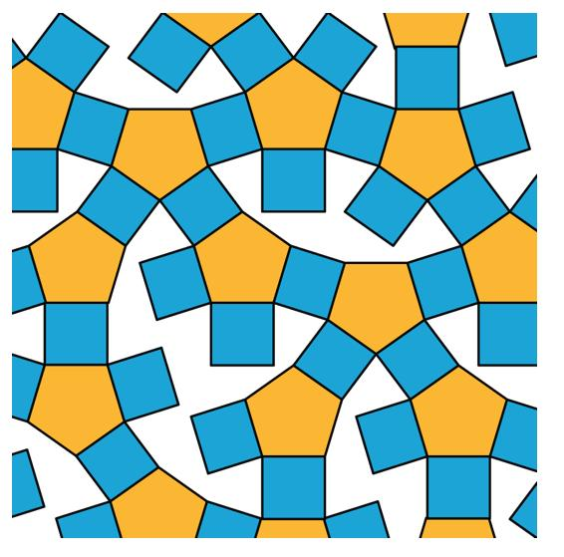
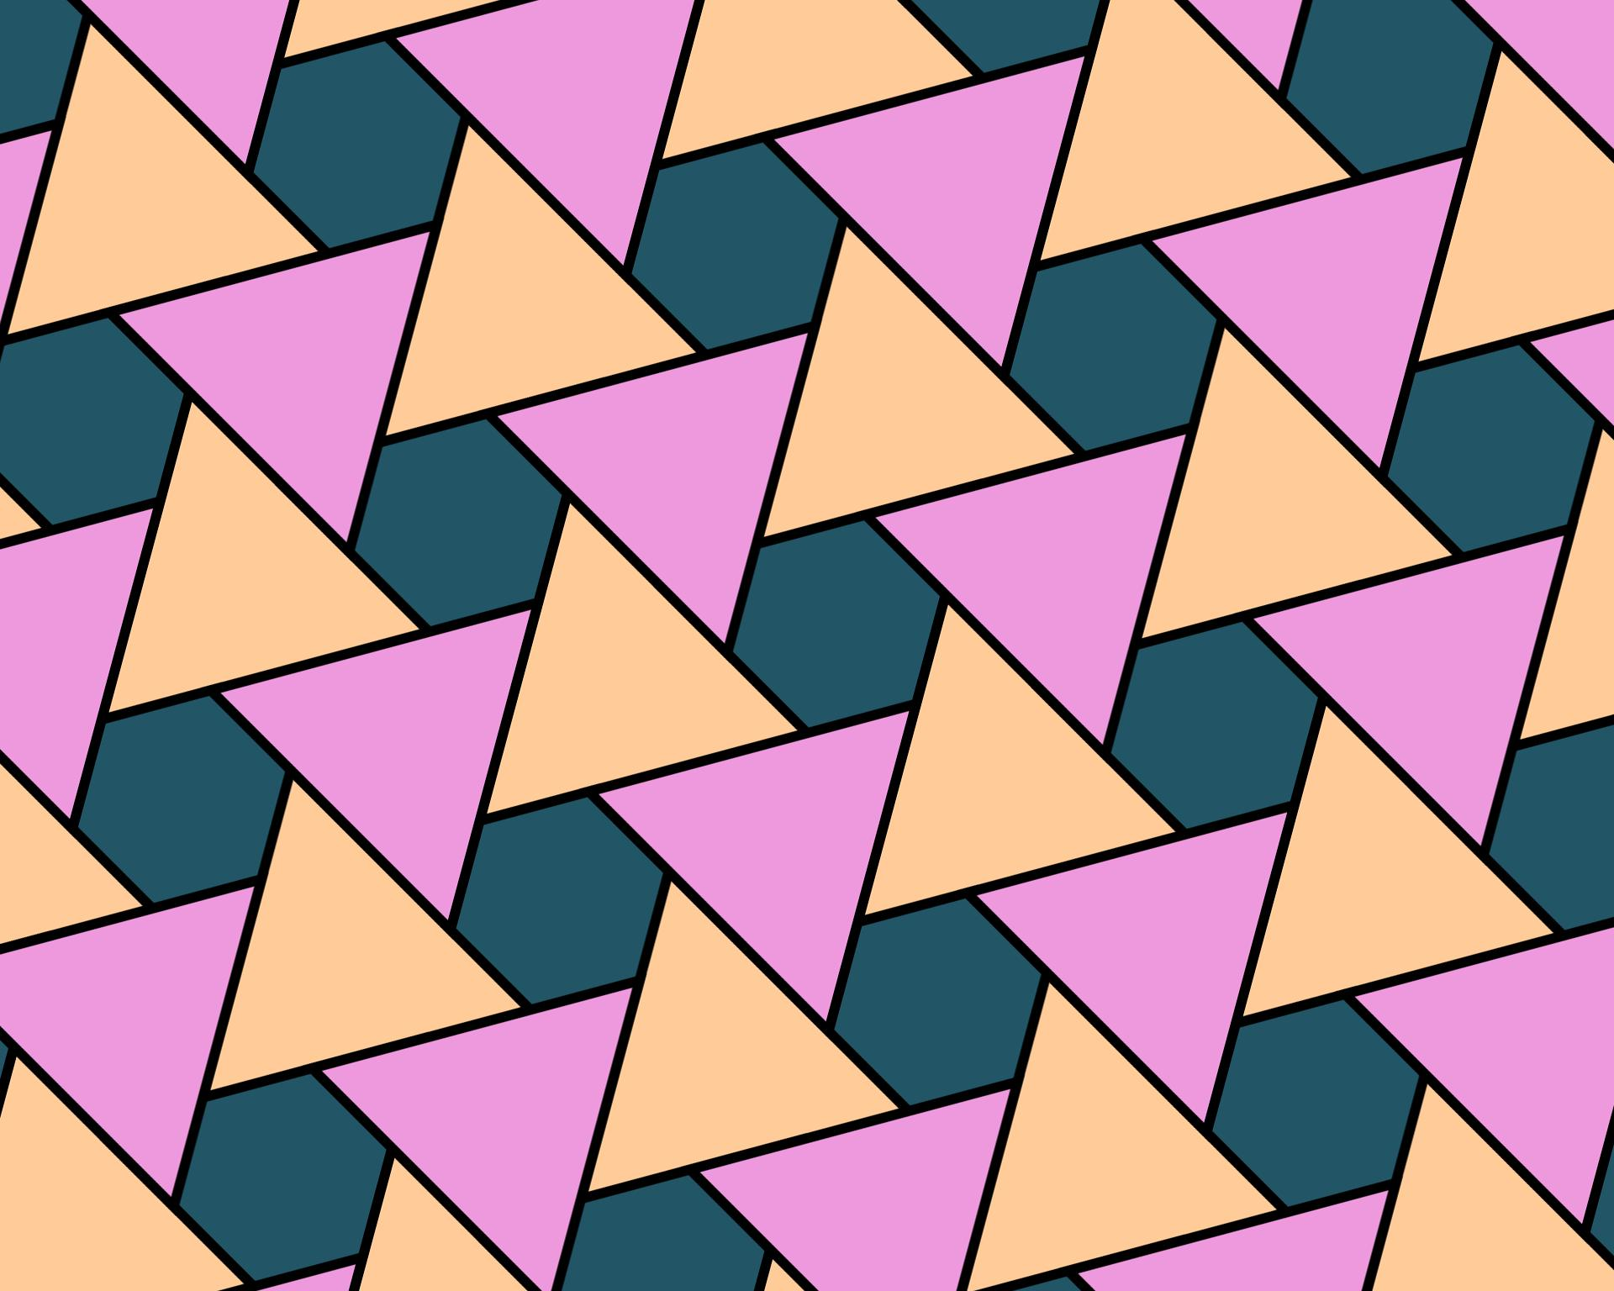
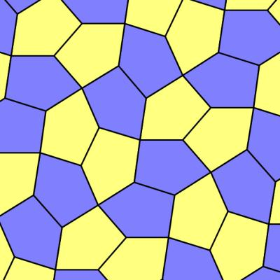

Key Points
# Source: AI Source: Provided by: [Data Path: Persons Table -> ID Column: 1, Name_En Column: Motasem Essam] -> From: [ChatGPT] on [7/25/2026]
- Irregular Polygon Tessellation uses irregular polygons to tile the plane.
- The polygons can be convex or concave, although particular tilings may impose additional restrictions.
- It can use one irregular polygon type or multiple types.
- It can therefore include monotile and multi-tile examples.
- The polygons must cover the plane without gaps or overlaps.
- The angles around a vertex must fit together appropriately, but angle sums alone do not guarantee a complete tessellation.
- Some irregular triangles can tessellate the plane.
- Certain irregular pentagons can tessellate the plane.
- It is different from a semi-regular tessellation because semi-regular tessellations use regular polygons. (Mathwords)
- Periodicity is a separate property: an irregular polygon tessellation may be periodic or non-periodic.

Conclusion
# Source: AI Source: Provided by: [Data Path: Persons Table -> ID Column: 1, Name_En Column: Motasem Essam] -> From: [ChatGPT] on [7/25/2026]
$$\boxed{\text{Irregular Polygon Tessellation}=\text{Tessellation formed from irregular polygons}}$$
Its most important feature is the irregularity of the polygonal tiles, rather than the number of tile types or whether the pattern repeats.
For your taxonomy:
$$\boxed{\text{Irregular Tessellations}→\text{Irregular Polygon Tessellation}}$$
and:
$$\boxed{\text{Irregular Polygon Tessellation}→\left\{\begin{matrix}\text{Irregular Monotile Tessellation} \\ \text{Irregular Multi-Tile Tessellation}\end{matrix}\right.}$$

